**Name .priti yadav**

**Roll no .106**

**Class .FYIT**

**{ PRACTICAL NO : 1 }**

**INDEX…**

**Introduction and Contribution to Wikipedia**

**a) Description about Wikipedia and its features**

**b) Creating Account on Wikipedia**

**c) Creating your page on Wikipedia**

**d) Editing your page on Wikipedia.**

**Introduction and Contribution to Wikipedia**

**[A] Description about Wikipedia and its features**

**Wikipedia is a free, open content online encyclopedia created through the collaborative effort of a community of users known as Wikipedians. Anyone registered on the site can create an article for publication; registration is not required to edit articles. The site's name comes from wiki, a server program that enables anyone to edit Web site content through their Web browser.**

**Jimmy Wales and Larry Sanger co-founded Wikipedia as an offshoot of an earlier encyclopedia project, Nupedia, in January 2001. Originally, Wikipedia was created to provide content for Nupedia. However, as the wiki site became established it soon grew beyond the scope of the earlier project. As of January 2015, the website provided well over five million articles in English and more than that number in all other languages combined. At that same time, Alexa ranked Wikipedia as the seventh-most popular site on the Internet. Wikipedia was the only non-commercial site of the top ten. { Wikipedia Homepage }**

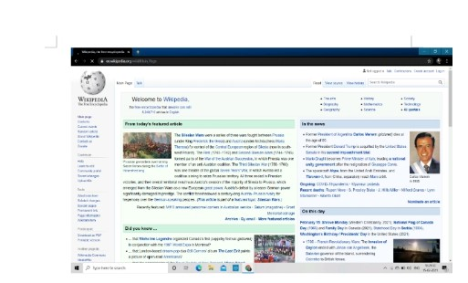**Criticisms of Wikipedia include assertions that its openness makes it unreliable and unauthorative. Because articles don't include bylines, authors aren't publicly accountable for what they write. Similarly, because anyone can edit any article, the site's entries are vulnerable to unscrupulous edits. In August 2007, Virgil Griffiths created a site, Wikiscanner, where users could track the sources of edits to Wikipedia entries. Griffiths reported that self-serving edits typically involved whitewashing or removal of criticism of a person or organization or, conversely, insertion of negative comments into the entry about a competitor. Wikipedia depends upon the vigilance of editors to find and reverse such changes to content.**

**Features of Wikipedia :**

**1. Wikis can be edited by multiple approved people.**

**2. All edits are tracked in the page’s history.**

**3. Linking between pages on a wiki is very simple.**

**4. Pages are automatically placed in a list of all pages.**

**5. A recent changes page shows all edits made to the wiki.**

**6. Any bad edits can be easily reverted**

**7. Note taking.**

**8. Knowledge management.**

**9. Community Websites.**

**10. Intranets.**

**b) Creating Account on Wikipedia:**

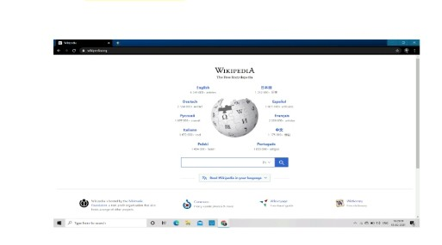**Go to www.wikipedia.org and choose "English"**

**Click "Create account" on the upper right side of your browser**



**Click here to create account**

**Enter your account information and the captcha, and click "Create Account".**

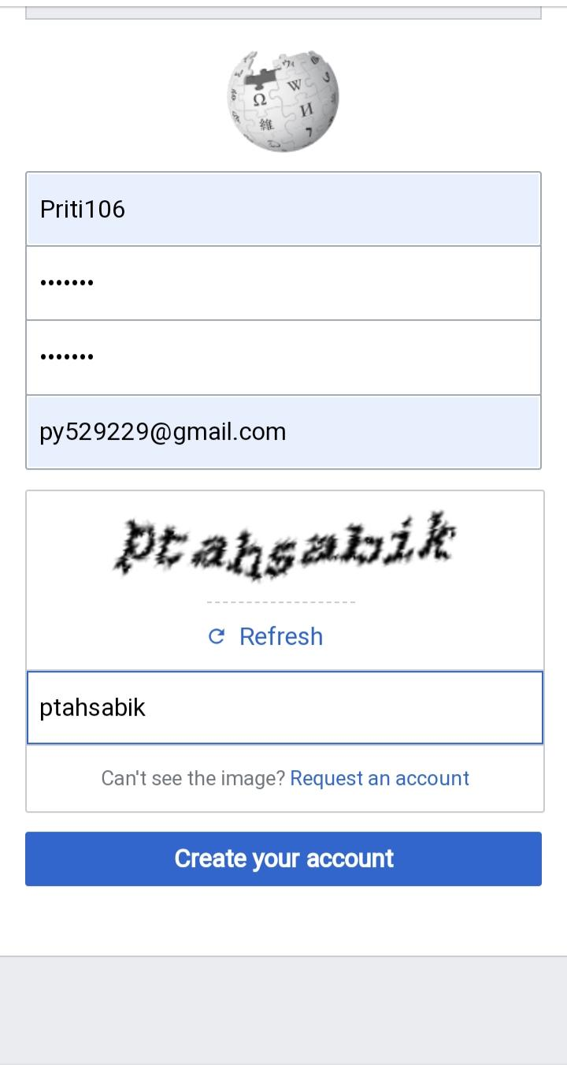**After creating account this page will appear:**

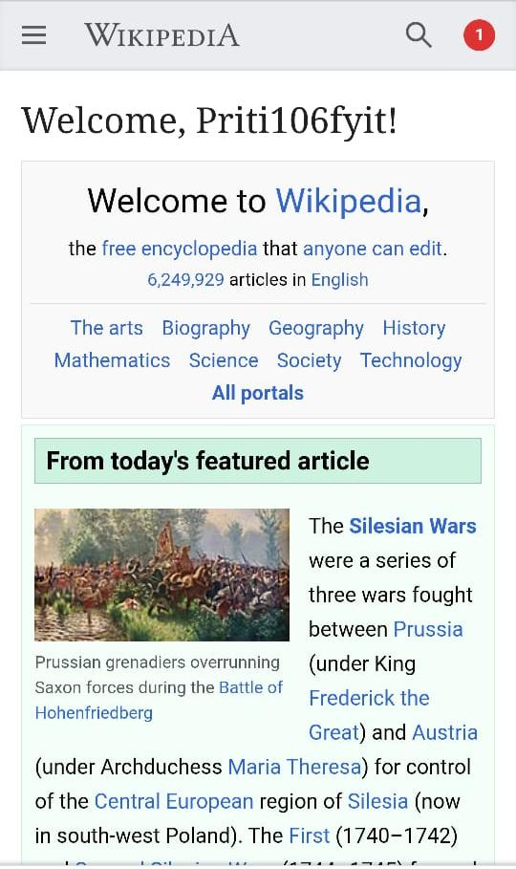**c) Creating your page on Wikipedia:**

**1. To create a Wikipedia.org page, you must have a registered account. Log in or create one.**

**2. Click on your account**

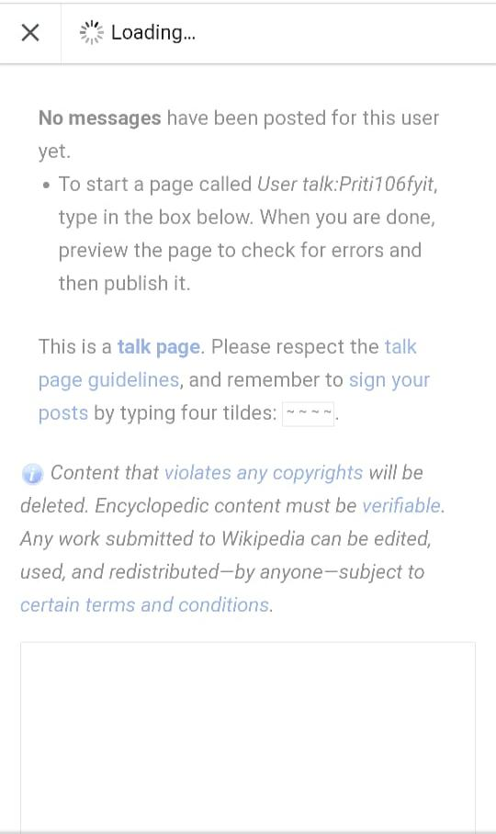

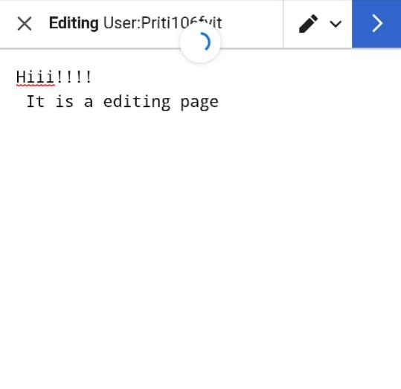**5. You have to write the content you want in your Wikipedia page as shown in the image below**

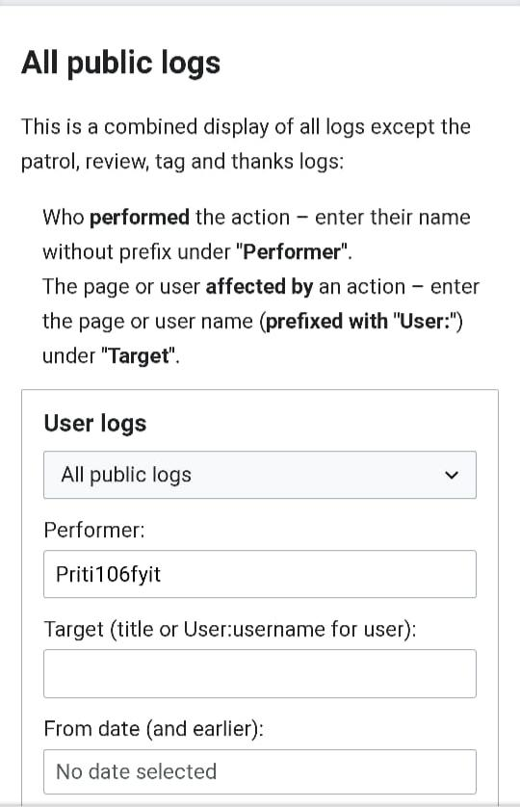**5. You have to write the content you want**

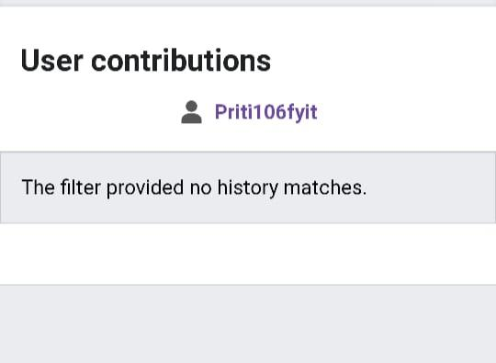**Click the view history then will appear history page**

**d) Editing your page on Wikipedia:**

**1)Go to the page you want to edit**

**2) Click on edit source**

